## EX1

-Enter number

-Print “Yes” if number greater than 10 otherwise, print “No”

Q1: Write output following input in table below:

|  |  |
| --- | --- |
| Input | Output |
| 10 | No |
| 14 | Yes |
| 13 | Yes |
| 7 | No |

Q2: Draw flowchart on paper

START

Number=int(input())

number>10

Print(“NO”)

Print(“YES”)

END

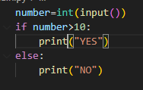Q3: Write code to solve the problem

## EX2

-Enter a string **number** in the console

- **n** is the length of **string**

-Print **sum of number in string e**xample: “123” = 6

**!! You can use only 1 print instruction!!**

Q1: Write output following input in table below:

|  |  |
| --- | --- |
| Input | Output |
| “12345” | 15 |
| “3457” | 19 |
| “1” | 1 |
| “67” | 13 |

Q2: Draw flowchart on paper

Q3: Write code to solve the problem

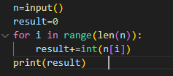

## EX3

-Enter a string **number** in the console

- **n** is the length of **string**

-Print **sum of even number in string e**xample: “1234” = 6

**!! You can use only 1 print instruction!!**

Q1: Write output following input in table below:

|  |  |
| --- | --- |
| Input | Output |
| “12345” |  |
| “3457” |  |
| “1” |  |
| “67” |  |

Q2: Draw flowchart on paper

Q3: Write code to solve the problem

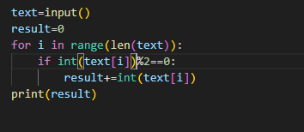

## EX4

-Enter a string **number** in the console

- **n** is the length of **string**

-Print **sum of number in string are greater or equal than 8 e**xamples: “5988” = 25

**!! You can use only 1 print instruction!!**

Q1: Write output following input in table below:

|  |  |
| --- | --- |
| Input | Output |
| “1780945” |  |
| “34857” |  |
| “1” |  |
| “997” |  |

Q2: Draw flowchart on paper

Q3: Write code to solve the problem

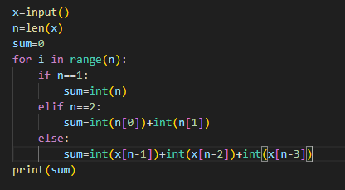

## EX5

-Enter a string in the console

- **n** is the length of **string**

-Print **number of letters in string and print “No letter A” if your string not containing letter A**

**!! You can use only 1 print instruction!!**

Q1: Write output following input in table below:

|  |  |
| --- | --- |
| Input | Output |
| “abcAdD” | 2 letters A |
| “abbbA” | 2 letters A |
| “BCD” | No letter A |
| “HKYD” | No letter A |

Q2: Draw flowchart on paper

Q3: Write code to solve the problem

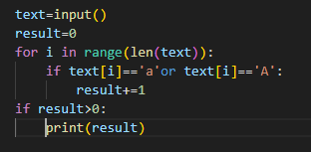

## EX6

-Enter a number **n** in the console

-Print a reversed triangle of X (see examples)

**!! You can use only 1 print instruction!!**

Ex:

>4

>XXXX

>XXX

>XX

>X

Q1: Write output following input in table below:

|  |  |
| --- | --- |
| Input | Output |
| 3 |  |
| 2 |  |

Q2: Draw flowchart on paper

Q3: Write code to solve the problem

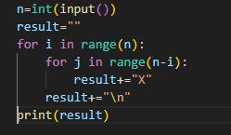

Note: here we **don’t allow** you to use this Python instruction:

myText = “X” * 10

Why? Because it’s too easy like this! **You need to learn to use 2 REPEAT-N-TIMES**

## EX7

-Enter a string in the console

- **n** is the length of **string**

-Print **reverse of string => Hi = iH**

**!! You can use only 1 print instruction!!**

Q1: Write output following input in table below:

|  |  |
| --- | --- |
| Input | Output |
| “hello” | olleh |
| “World” | dlroW |
| “Hack” | kcaH |
| “Yes” | seY |

Q2: Draw flowchart on paper

Q3: Write code to solve the problem

